**Project Report Template**

1. **INTRODUCTION**
   1. **Overview**

**This report delves into the fascinating realm of business expenses and provides a visual exploration of the various expenditures incurred by different businesses.**

* 1. **Purpose**

**The visual representations allow for intuitive analysis, facilitating a deeper understanding of expenditure patterns and their implications for business performance.**

**To Extract the insights from the data and put the data in the form of visualizations , Dashboards and Story we employed Tableau tool.**

1. **Problem Definition & Design Thinking**

**2.1 Empathy Map**

**I am already uploaded Empathy Map in Git hub**

**2.2 Ideation & Brainstorming Map**

**I am already uploaded Ideation & Brainstorming Map**

1. **RESULT**

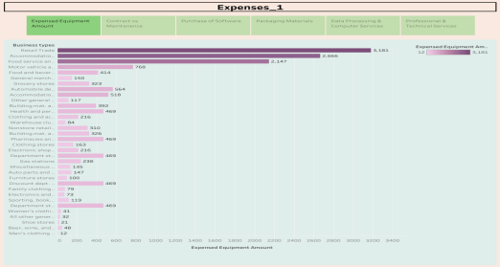 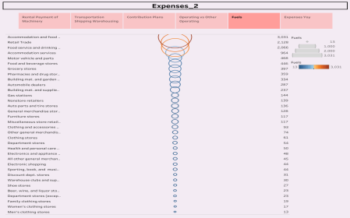

**4. CONCLUSION**

**Decision-makers, financial analysts, and stakeholders can gain valuable insights into the financial health of businesses, identify areas of inefficiency or opportunity, and make informed decisions to optimize resources and drive growth.**

**Dashboard 1 displays Expense breakdown from insights into diverse business costs, Dashboard 2 displays Business Expenditure Overview and then Dashboard 3 displays Expense insights.**

**Story 1 and 2 displays Estimation of Business Expenses overview.**

**5. FUTURE SCOPE**

* **Need for business communication.**
* **More than effort in their business.**
* **Start up begins with the end**
* **Own business are successful in their**

**lives**